HEADER SECTION

Is there any way that black square is not seen? It doesn’t look good, especially in the mobile version. That needs to blend with the background.
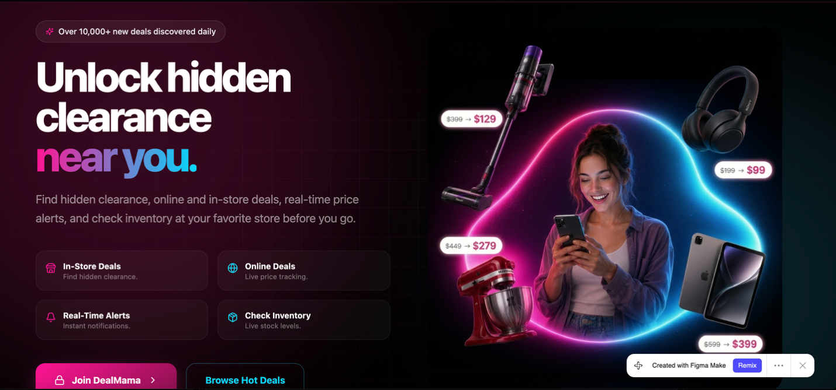

HOT DEALS. REAL SAVINGS Section

Too many blocks inside each deal card.

Do something similar to the below without block for pricing.
Also without date posted.
All in dark theme
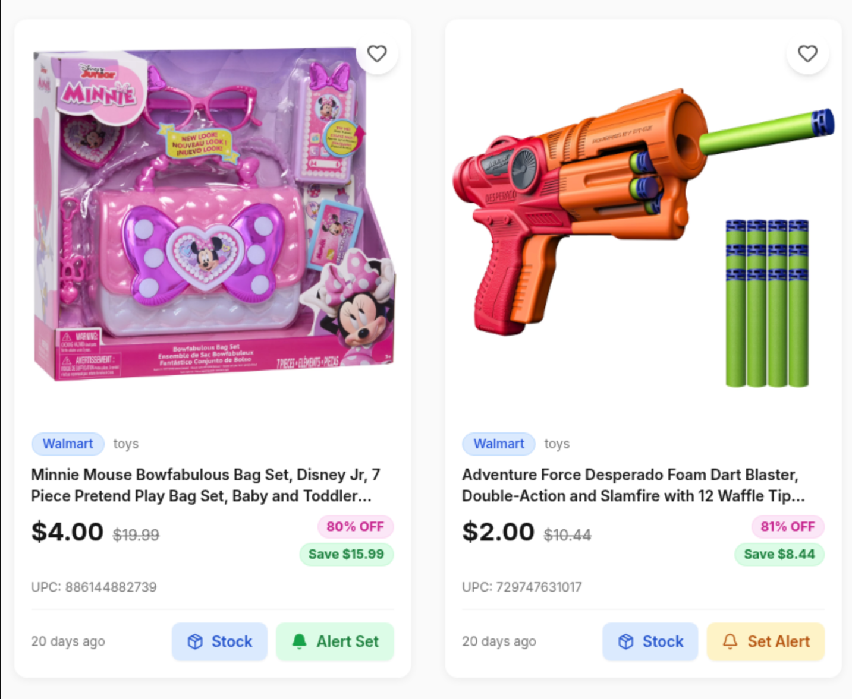

The HOW IT WORKS buttons/tabs need to have the same hover effect as the Unlock clearance by zip code section.

After that is done, please remove the Unlock clearance by zip code section. We are not going to use it.

WHAT OUR MEMBERS ARE FINDING
I need those photos a little bigger. Not that much, but a little bit. I made a screenshot with a line to make it that size.
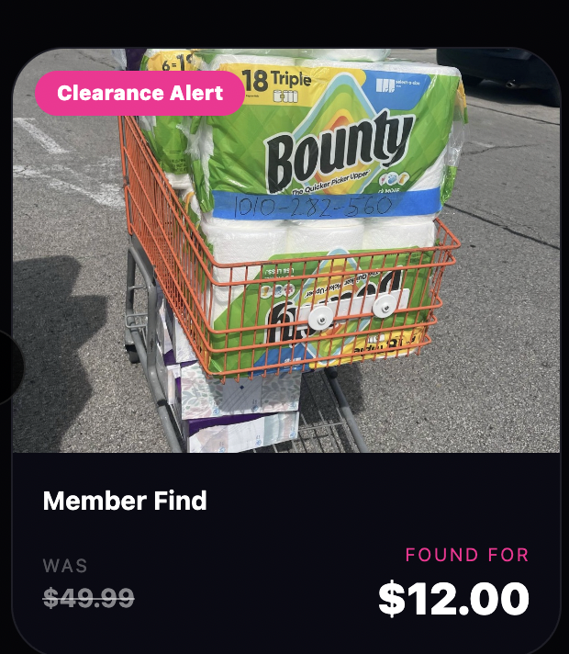

Footer
Change Twitter icon for TIK TOK icon

